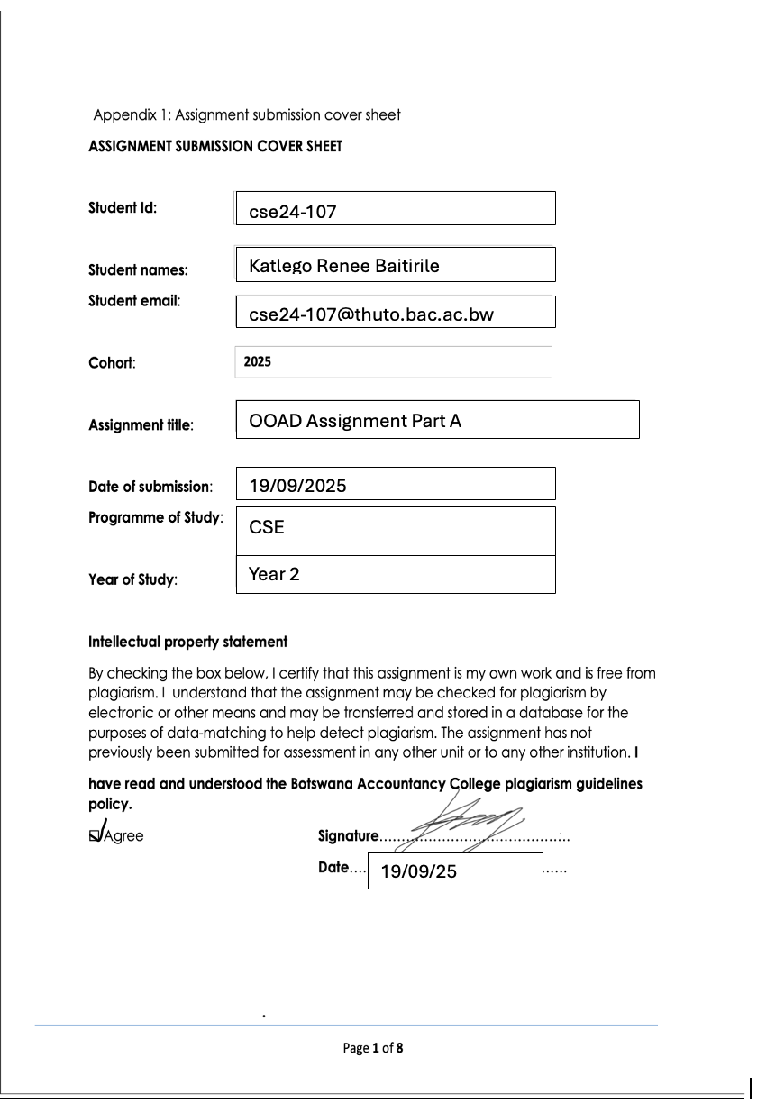
07/11/25
OOAD Testing report
INTERGRATION TESTING REPORT FOR BANKING SYSTEM
- Overview
To verify that the end to end functionality of the bank system by testing different scenarios. This is to ensure the core model, boundary classes, controllers and data access(text file) work together seamlessly as a single, cohesive application.

- Integration Tests and results

Test Case1:Successful Bank teller Login and Dashboard display
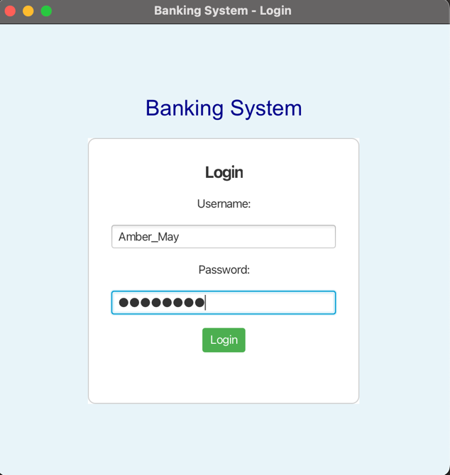
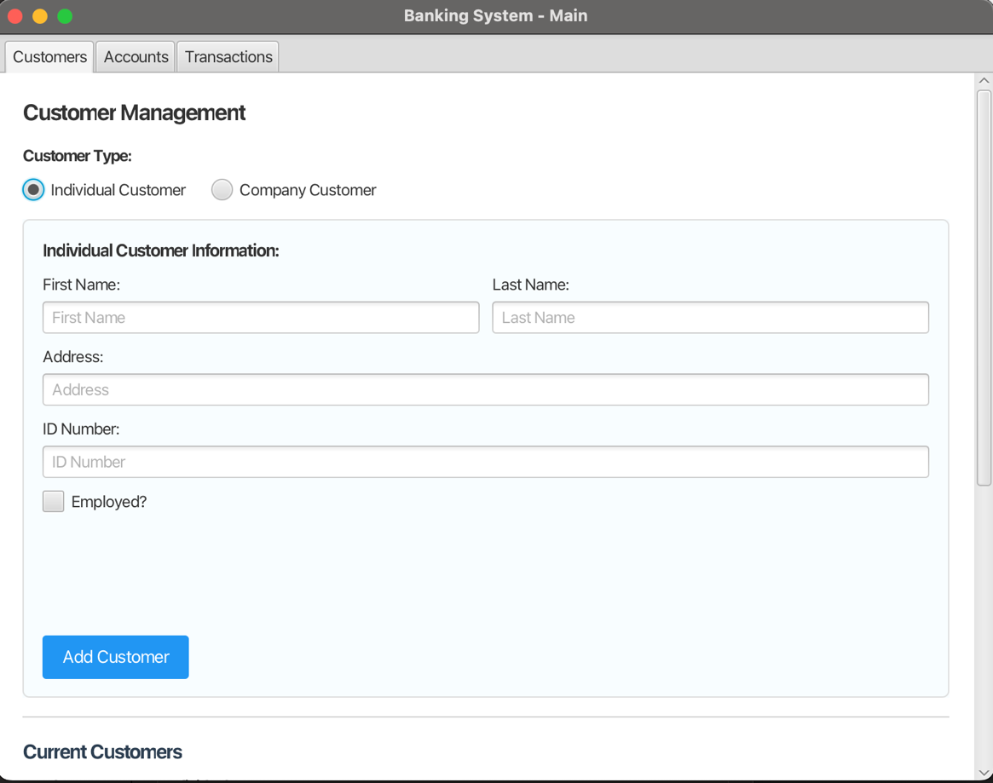
Using incorrect login details:
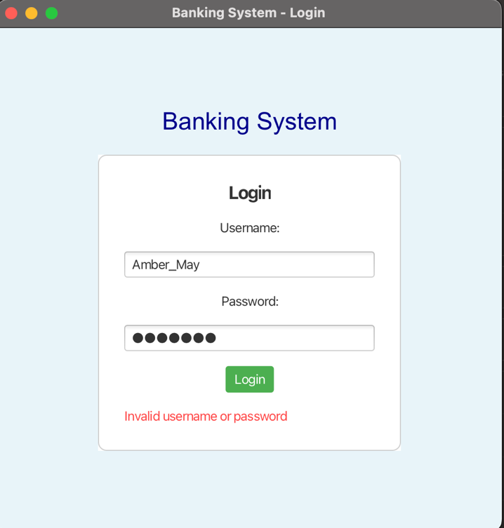

Test Case 2: Create customer account (unemployed, employed, company)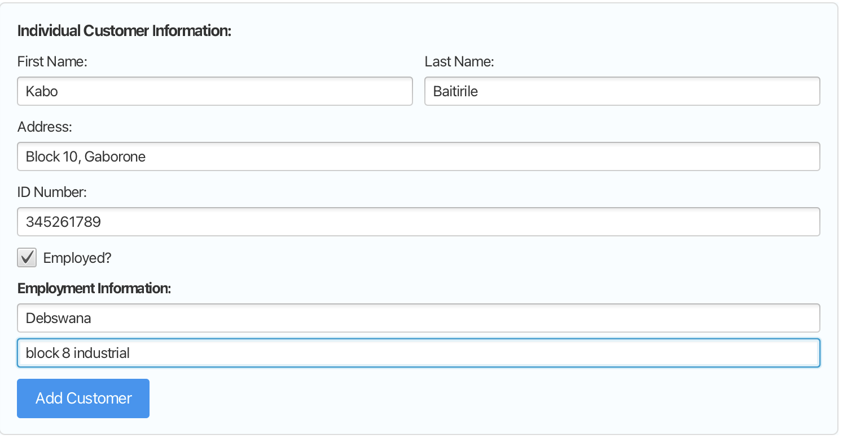
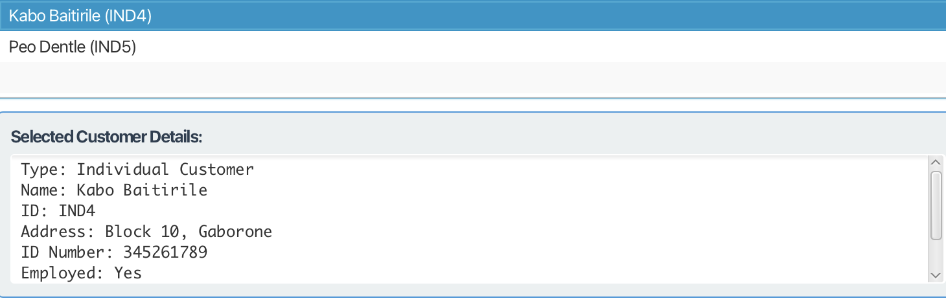
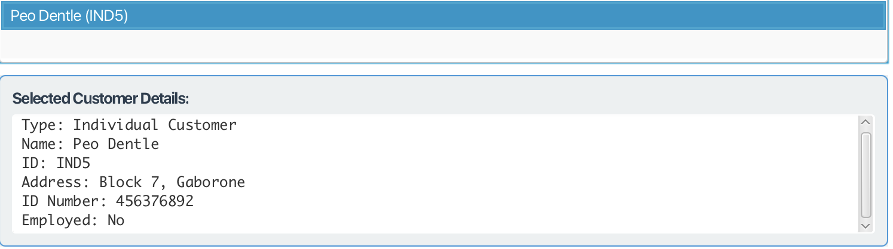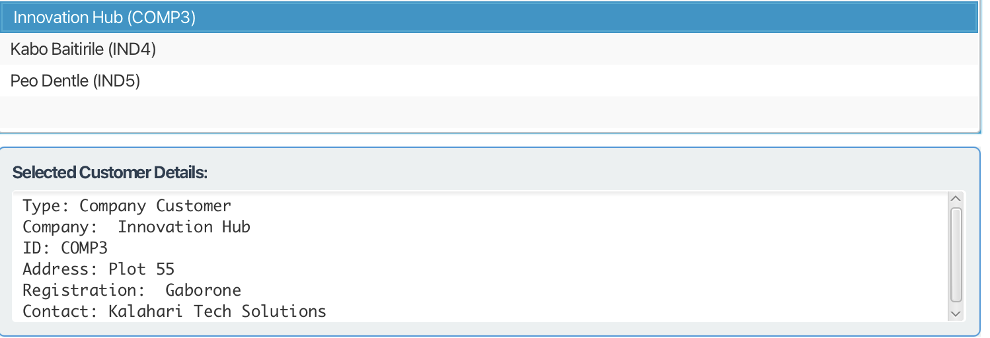
Test Case 3: Create Cheque Account for Employed and Unemplyed customer
Employed: Kabo Baitirile
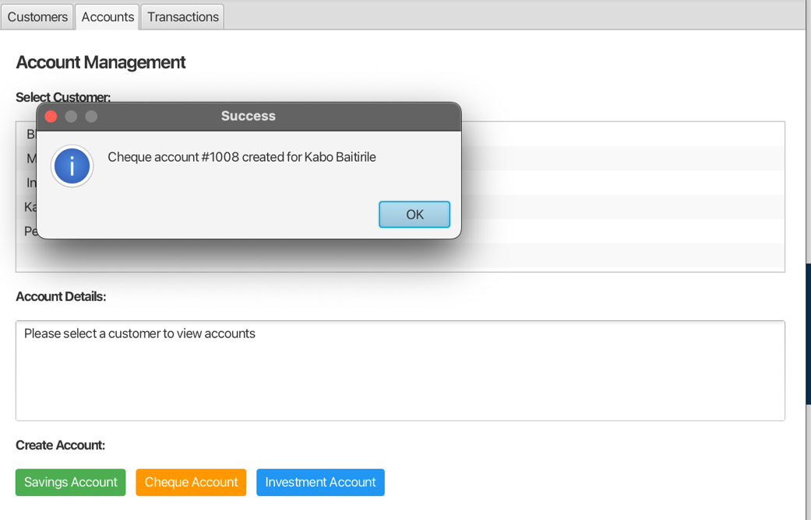
Unemployed: Peo Dentle
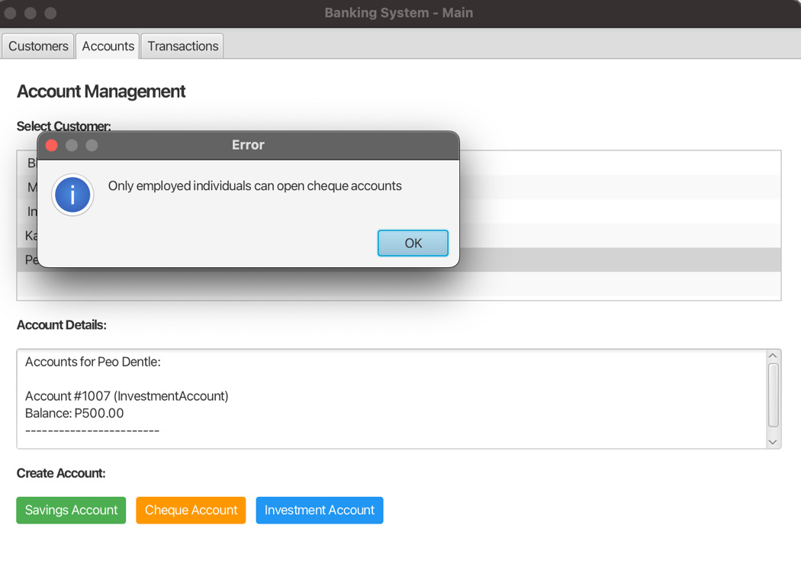

Test Case 4: Deposit funds in accounts and withdraw P200.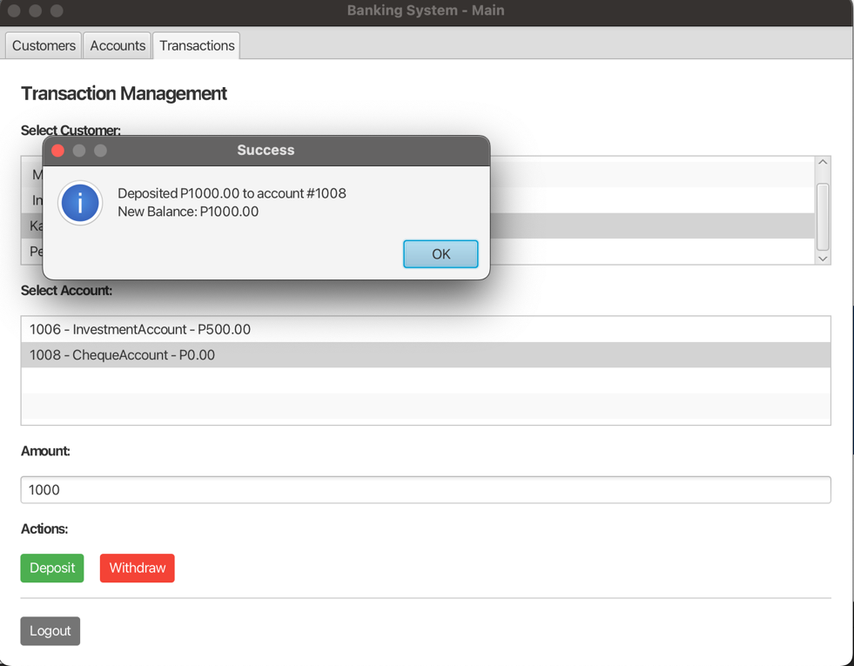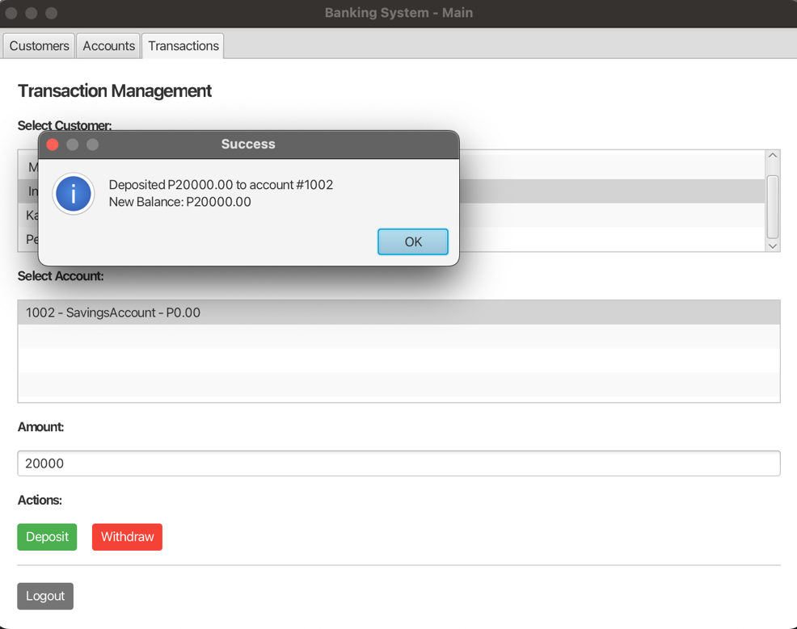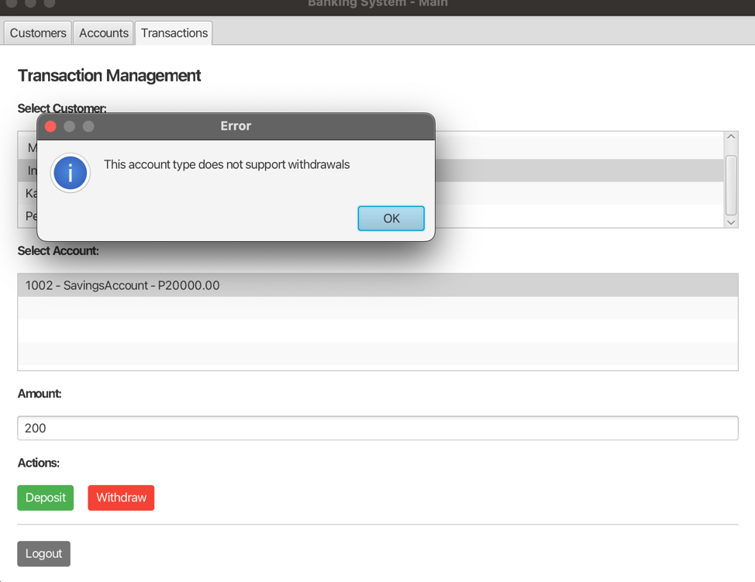

Test Case 5: Log out
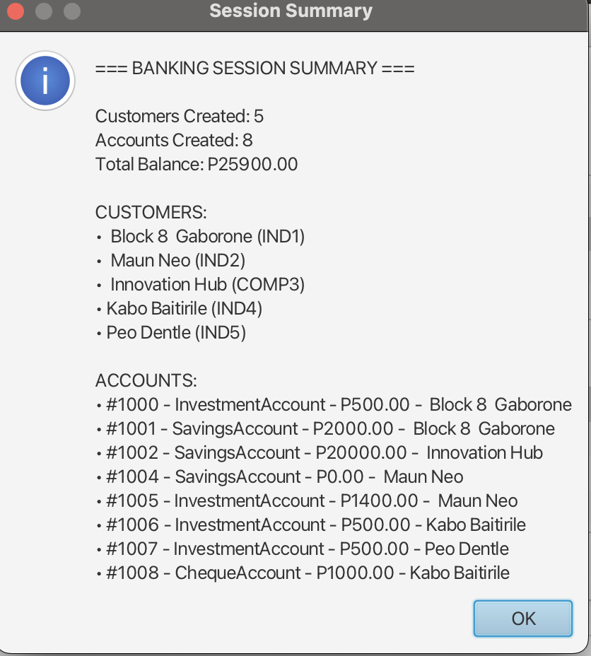
Test Case 6: The text file for accounts
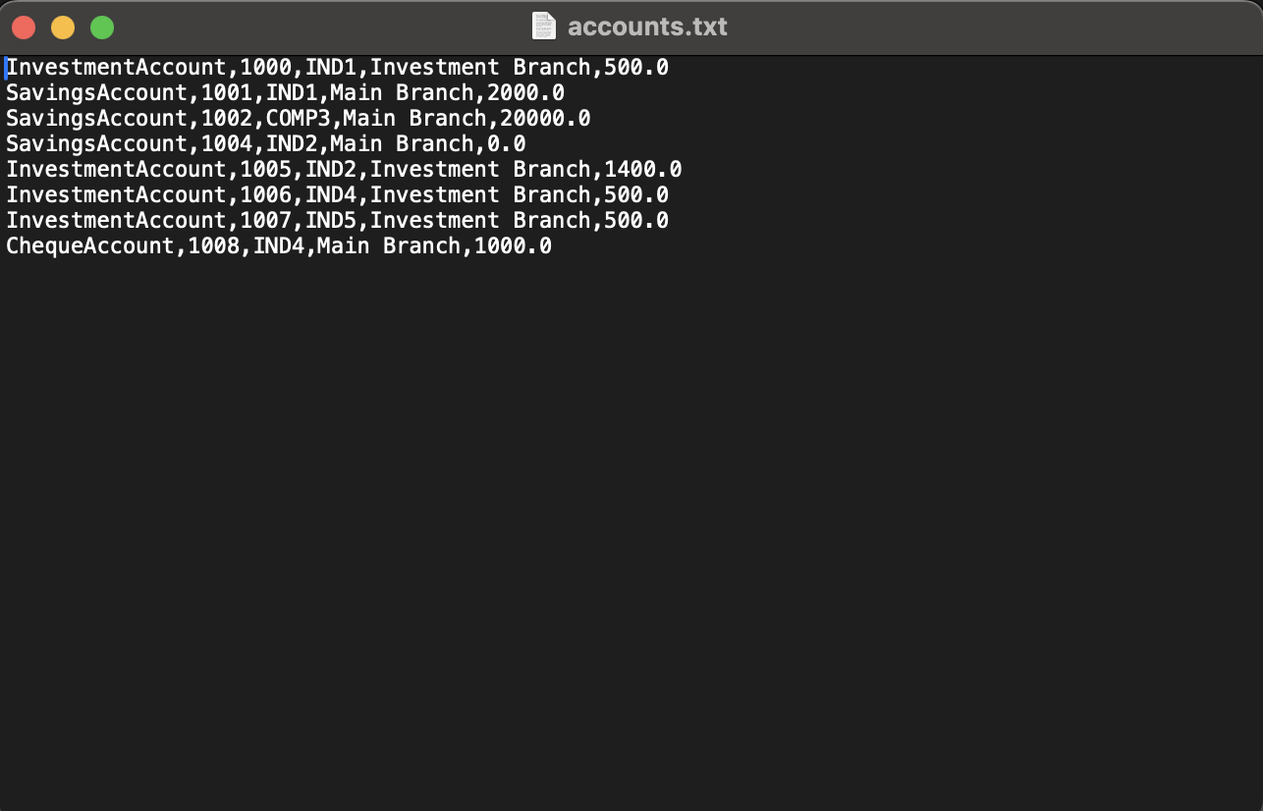
- Defects
- Incorrect labelling in some of the current customers details list.
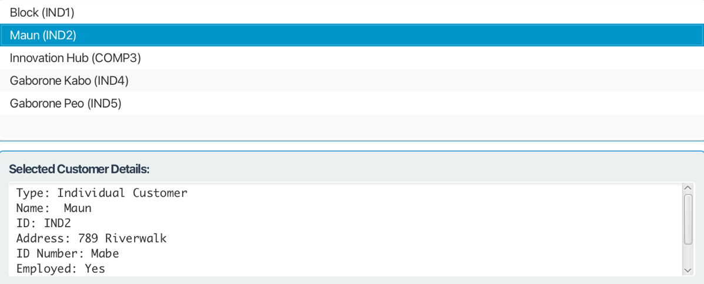
- Not immediatley asking me to deposit minimum P500 when creating investment account and just depositing it automatically.
- Conclusion
- The integration process was successful. All crutial user flows (log in, creating accounts, adding accounts and depositing ) work as intended.Two defects were idnetified but do not prevent core functionality.

